**Design Phase**

Problem Statement

**Use Case Diagram**

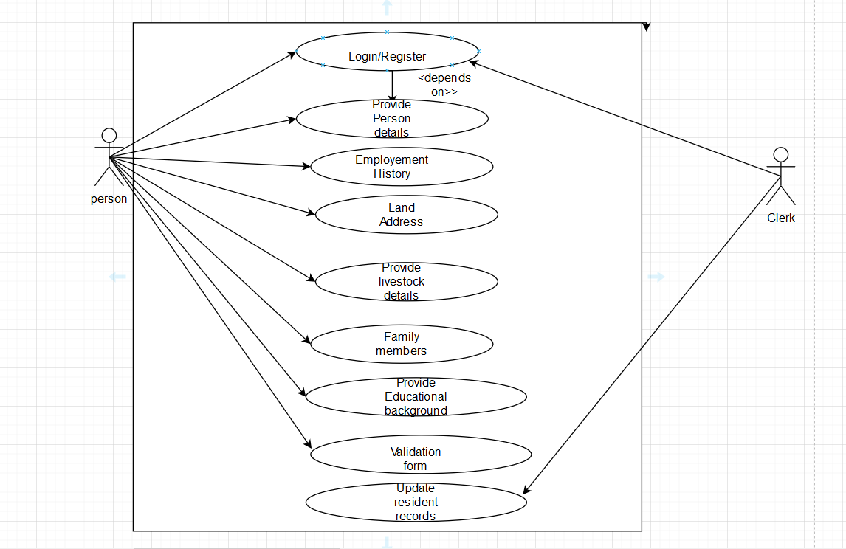

**Overview Of ERD**

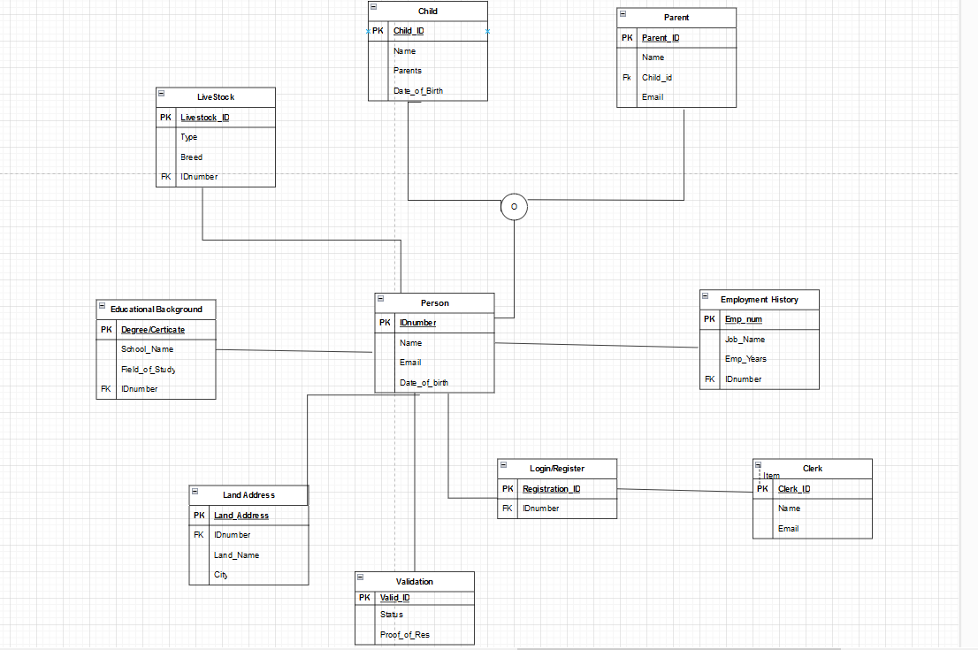

**Detailed ERD**

